The transition to spot energy pricing: Is this a sustainable solution for Iren’s Bitcoin Mining?
Iren made headlines this summer when they released their July monthly update which showed them suddenly mining bitcoin at a loss compared to the 40%+ gross margins in previous months. This coincided with a short report and a yen carry blowup that together caused the stock to retrace more than 50% in a couple of weeks.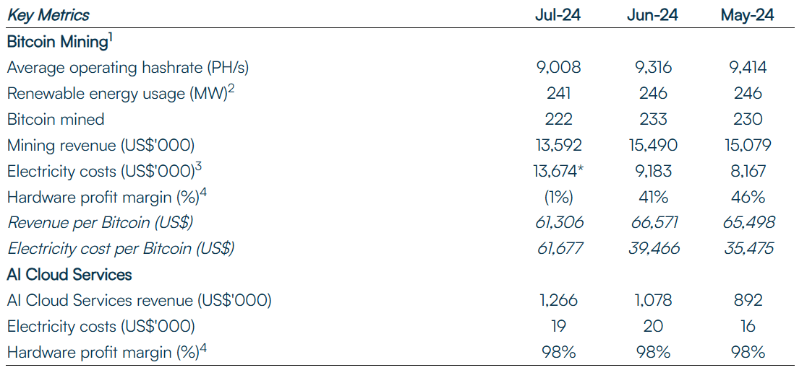
So, what happened to cause their energy costs to blow up? Iren purchased a hedge in the that allowed them to purchase electric at a fixed price. This is important in ERCOT where the market is more deregulated and prone to supply demand imbalances which can cause extreme volatility in electric prices.

Consider the following: Based on Iren’s monthly report their realized electrical cost was approximately $.076 per KWh. So, let’s say they purchased an agreement to buy at $.07 per KWh. Most of the month the cost is well below that price, but ERCOT can see energy prices soar up to $5 per KWh during peak demand. This can make mining very unprofitable. In fact, if we look at July 2023, we see there were 133 hours in LZ west (Iren’s ERCOT Zone) where the real time electricity price were higher than $.07 and averaged $.222 per KWh during those hours. When scaled up to the 241 MWs that were operational during the month, we can see how beneficial this hedge can be.
Quick Math Below:
July 2023 (Assuming same electrical usage):
133*(.222-.07) * (1000*241) = ~$4.87 million
July 2024:
103*(.105-.07) * (1000*241) = ~$886K
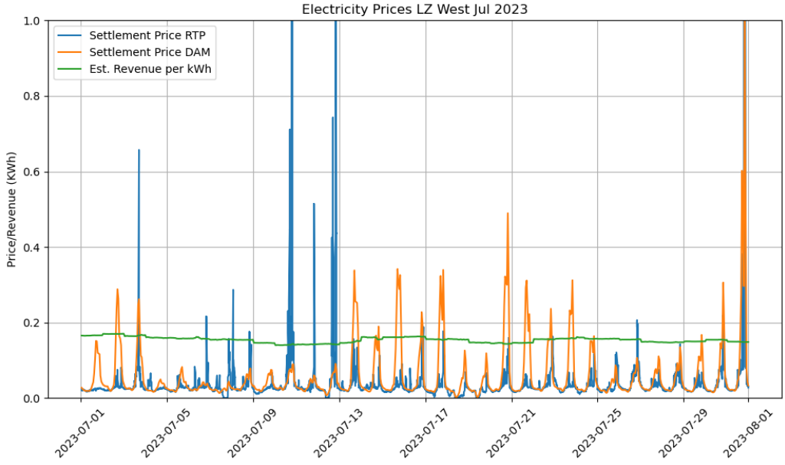
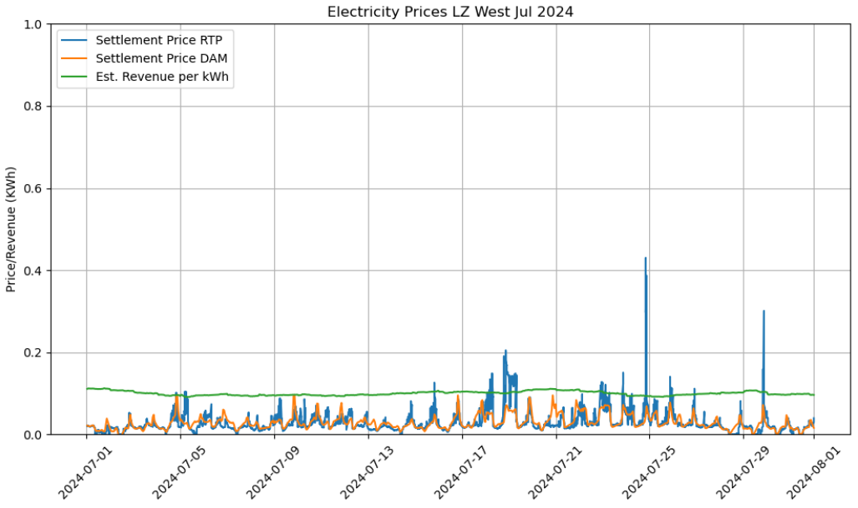
As you can see this method only benefits from the volatility of energy pricing. It’s unclear the exact details of the hedge but below are graphs of July 2023 vs July 2024 so you can visually see the difference in this volatility and the reason why it was unsuccessful. (I included both real time prices and the day ahead market as you can probably monetize both)

The average real time market price for July 2024 compared to July 2023 was $.044 vs $.029. Which may not seem like a lot, but that is over a 50% increase. However, if you can curtail this electrical load and only pay for it when it is below the estimated mining revenue line (green) you would only be paying $.031 and $.026 for the same time periods.
Did something in ERCOT’s LZ West Change?
My initial question was there something that changed in ERCOT itself that suppressed the volatility pricing? ERCOT’s market is always growing and adding new energy producers so from the outside it’s hard to exactly pinpoint. But, I think a lot of upgrades have been made to the grid after the 2021 ice storm most notably more battery storage (Battery Storage). Specifically in Iren’s case, Childress added a new solar project at the end of 2024, but that only came online (supposedly) in December 2024 so that probably didn’t impact July. (link)
I then analyzed the last 5 years of ERCOT data to see if I could see this trend. It seems that 2024 had more stable prices when compared to 2023 and parts of 2022, but fairly similar to 2020 and 2021.
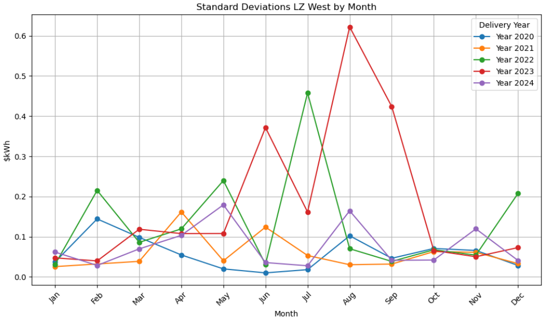
Note: I excluded February 2021 from all historical analyses (Texas Ice storm)
I also looked at the spread of prices as a whole and compared 2020-2023 to 2024 below. We can on a monthly basis, electric prices have been lower this year than the previous 4 (red bars are lower than green bars).
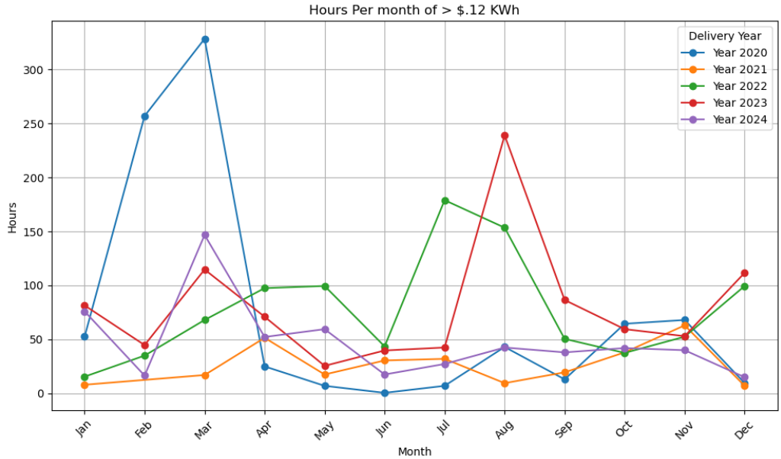
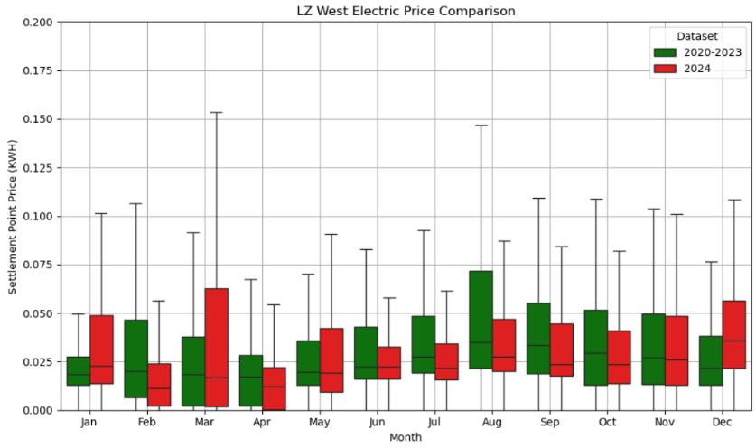
Since Bitcoin mining is a flexible load, we can curtail the load when prices are too high. Below are the number of hours each month where electric prices exceed the approximate revenue Iren currently brings in based off their efficiency and present bitcoin mining economics. It appears there should be a day or two each month where miners should be offline, not a huge deal. However, if IREN brings HPC to Texas this is a factor to consider, and they may want to consider another hedging strategy.
Conclusion: ERCOT, and West Texas in particular, offer some of the lowest-cost green energy sources, making it an ideal location for Bitcoin mining. However, it's important to note that the metrics presented in this report are based on generalized data publicly available from ERCOT, and they do not account for any specific agreements Iren might have with utilities. Given the grid-friendly nature of Bitcoin mining, it's reasonable to assume that Iren secures even more competitive electricity rates.

I am highly confident in Iren's capability to scale its operations more efficiently, given that the bulk of its megawatts (MWs) are located in West Texas. I am particularly optimistic about Iren's potential to continue demonstrating industry-leading costs, especially at their Childress site. Iren stands out among Bitcoin miners with its remarkable progress throughout 2024, and I anticipate this positive trend will persist.

